How to move the new routine to GIT central repository

1. Copy the routine to clone path(C:\Projects\ocean\ocean-lbg\LBG.BP)in your system
2. Open git bash
3. Go the path where the repository is cloned.

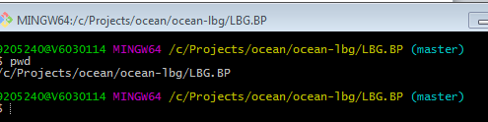

1. Now you need to use git status to check where the new routines moved are appearing.

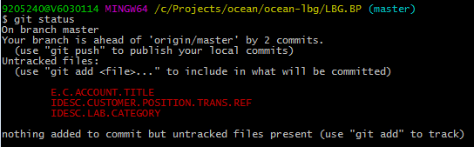

1. Next we need to push the routines by using git push

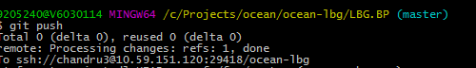

1. Once again use git add . check



1. Now git status to check whether routines are pushed.

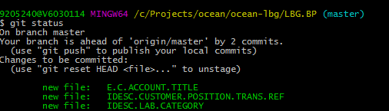

1. git commit -m "craig routines" to know commit message

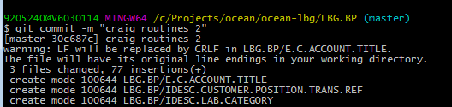

1. now once again use git status to check

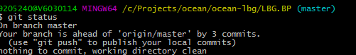

1. now use git push

